8 Social Studies
Mr. Kavanaugh
Location: Room 408 Email: justin.kavanaugh@hrce.ca Phone: 902-493-5124 Website: http://hpj.hrsb.ca/

Mrs. C. Christianson  PRINCIPAL | Mr. L. Matheson  VICE-PRINCIPAL | Mr. E. Lang  GUIDANCE

Social Studies helps learners develop critical thinking abilities and enables them to participate in society as well-informed and engaged citizens. The goal of Social Studies education is to help learners understand their place in the world through inquiry, an appreciation of first-voice, an understanding of place, collaboration, decision-making, perspectives and worldview, recognizing bias, interpreting primary and secondary sources, communicating for social studies purposes, and advocacy.

Topics:
Canadian Identity
Learners will investigate values and traditions, identities and histories.
Physical Geography
Learners will investigate the climate, landforms, and regions of Canada coast to coast.
Learners will analyse the ways in which geography influences a people’s identity.
The Evolution of Canada’s Past
Learners will evaluate Canada’s role in global affairs.
Learners will analyse Canada’s changes as it evolved into what we know today.
Citizenship
Learners will evaluate their political identity and what it means to be a good citizen.
The Future of Canadian Society
Learners will analyse contemporary issues and try to uncover future ones.
Learners will analyse the balance of power and how to make things more equitable.

Evaluations and Assessments:
Formative Assessment (day-to-day ongoing student monitoring)
Class Participation (discussions, debates, question period, etc.)
Individual and Group Projects (Inquiry based focus)
Summative Assessments (Written and Oral Assessments)

Student work will be posted in google classroom (parents can request invitation)
Extra help will take place every day from 12:20 - 12:55 (Lunch) unless otherwise communicated.
Curricula Renewal Grade 7 & 8

Over the past school year, teams of teachers have worked at the Nova Scotia Department of Education and Early Childhood Development to renew curricula for grades 7 and 8 using a universal design for learning approach to support student-centred learning.

Highland Park was selected to pilot the new, draft curricula.

Universal Design for Learning:
Universal design for learning encompasses curricula design, learning resources, instruction, and assessment practices that guide the development of a flexible learning environment focused on accommodating and supporting individual learning needs.
Inquiry Based Learning: Learners are engaged in the learning process and they make decisions and take ownership and responsibility for their learning and discovery. Inquiry can be a guided or an open process, allowing learners to identify questions for investigation and independently or collaboratively design a plan to discover meaning.
Cross-curricular/ project-based learning:
An instructional method in which learners perform an active and dynamic exploration of authentic real-world problems and challenges.

A competency is an interrelated set of attitudes, skills and knowledge that is drawn upon and applied to a particular context for successful learning and living.

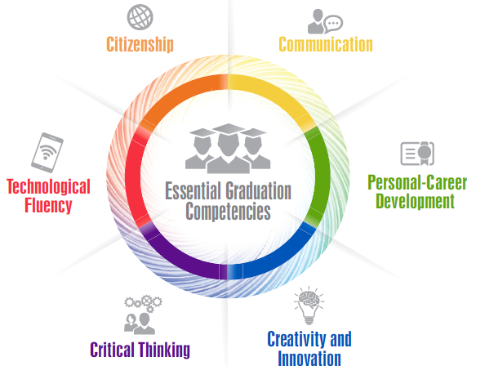

Competencies are developed over time through outcomes and a supportive learning environment.

