7 ENGLISH
Mr. Kavanaugh
Location: Room 408 Email: justin.kavanaugh@hrce.ca Phone: 902-493-5124 Website: http://hpj.hrsb.ca/

Mrs. C. Christianson  PRINCIPAL | Mr. L. Matheson  VICE-PRINCIPAL | Mr. E. Lang  GUIDANCE
English is designed to help learners understand their place in an ever-changing world, to appreciate different forms of art, and to engage intimately with a variety of texts. The goal of an English education is to help learners develop a sense of citizenship by engaging and enhancing the practical communication skills required to be successful in the future. We will focus on creativity and critical thinking and how they relate to effective communication. Emphasis will also be placed on the role of technology and how to prepare for future careers.

Topics:
Community
Learners will investigate the roots of personal identity and community.
Conflict
Learners will investigate how and why conflicts arise.
Learners will analyse how conflict is used in story-telling to create meaning.
Traditions, Values, Growth, and Change
Learners will investigate how traditions and values are represented in society.
Learners will analyse the ways in which values change and evolve.
Resolution
Learners will evaluate the methods and depictions of modern problem-resolution.
Perspective
Learners will analyse texts critically for accuracy and reliability.
Learners will analyse the causes and outcomes of bias while challenging their own.

Evaluations and Assessments:
Formative Assessment (day-to-day ongoing student monitoring)
Class Participation (discussions, debates, question period, etc.)
Individual and Group Projects (Inquiry based focus)
Summative Assessments (Written and Oral Assessments)

Students will be graded on 1-4 grading scale but will receive an overall grade on their report cards. Assessments will be recorded in Powerschool regularly throughout the year. It is a good idea to check in regularly to ensure your child is keeping up with their assignments. Student work will be posted in google classroom (parents can request invitation)

Curricula Renewal Grade 7 & 8

Over the past school year, teams of teachers have worked at the Nova Scotia Department of Education and Early Childhood Development to renew curricula for grades 7 and 8 using a universal design for learning approach to support student-centred learning.

Highland Park was selected to pilot the new, draft curricula.

Universal Design for Learning:
Universal design for learning encompasses curricula design, learning resources, instruction, and assessment practices that guide the development of a flexible learning environment focused on accommodating and supporting individual learning needs.
Inquiry Based Learning: Learners are engaged in the learning process and they make decisions and take ownership and responsibility for their learning and discovery. Inquiry can be a guided or an open process, allowing learners to identify questions for investigation and independently or collaboratively design a plan to discover meaning.
Cross-curricular/ project-based learning:
An instructional method in which learners perform an active and dynamic exploration of authentic real-world problems and challenges.

A competency is an interrelated set of attitudes, skills and knowledge that is drawn upon and applied to a particular context for successful learning and living.

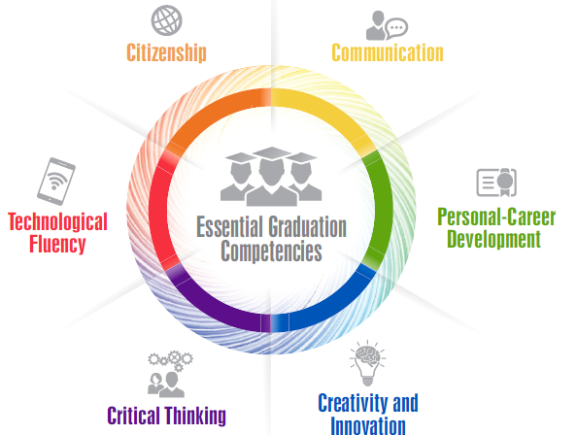

Competencies are developed over time through outcomes and a supportive learning environment.

